Local Environment setup for Copilot
- Install below software from software center (No admin rights are required).
  - Microsoft Visual Studio code
  - Node JS
  - GIT
  - Python
- Connect to office network(Copilot is accessible only inside office n/w), setup proxy in NPM and VS- code.
  - Setup NPM Proxy
    - Open command prompt or terminal or node cmd
    - Execute below command.
      - “npm config set proxy http://guardian.crimsonlogic.info:8080”
  - Setup Proxy in VS-code
    - Open VS code
    - GO to Setting
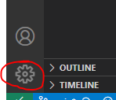
    - Search For Proxy and Setup proxy
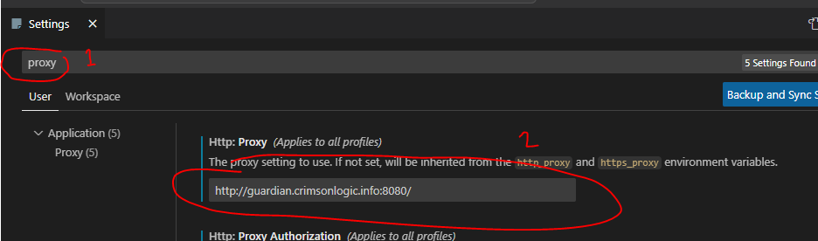
    - Uncheck strict SSL
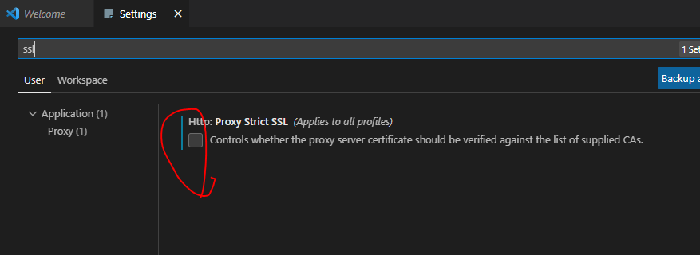
- Install the VS Code GitHub Copilot Extension
  - Open VS Code
  - Open Extensions and install GitHub copilot Extension.
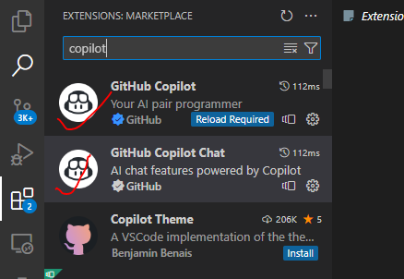

- Login to CL Enterprise GitHub on default browser (Use default browser for login)
  - Goto https://github.com/enterprises/clgthub
  - Click Continue
    - 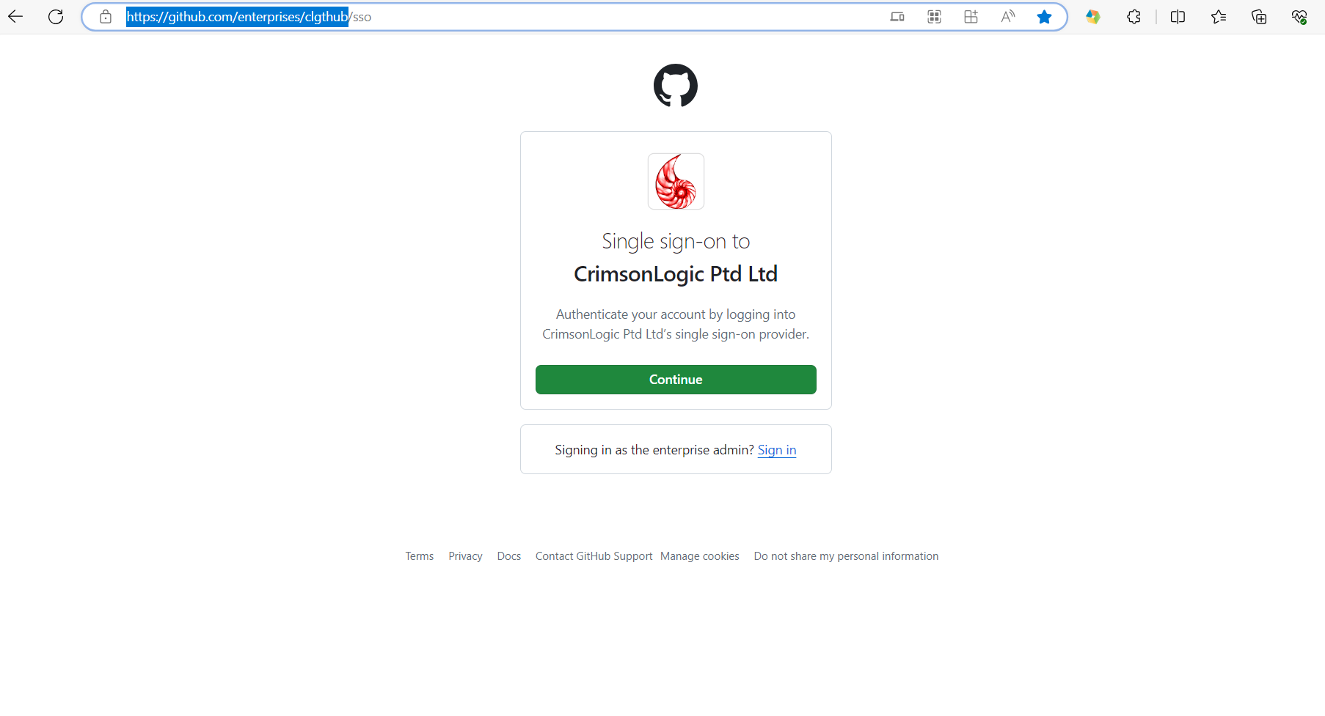
    - You will be redirected to below page.
      - 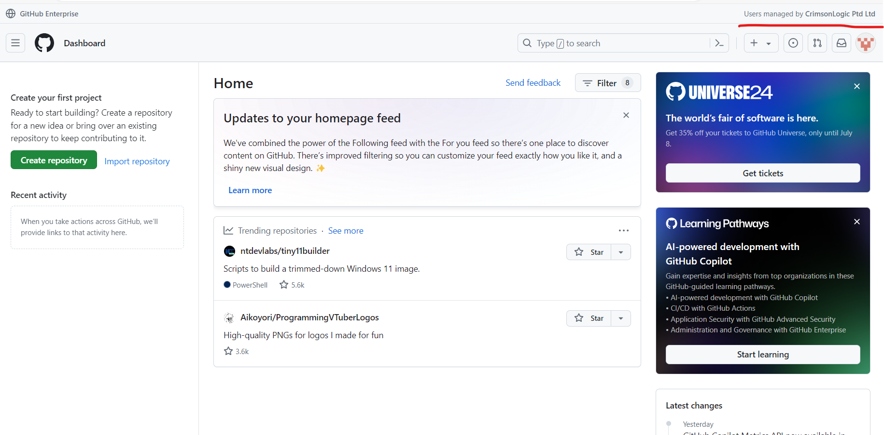
- Link GitHub account with VS code.
  - Goto Profile in Visual studio code
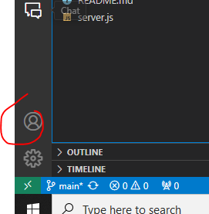
  - Click Login.
  - It will open the default browser for authorization.
  - Click authorize.
  - After Login, your account will be linked like below.
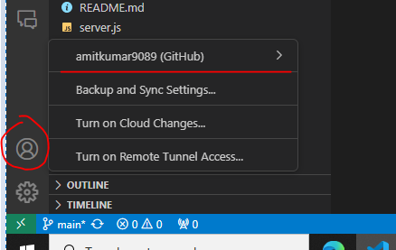
- Verify whether copilot chat is working.
    - Goto copilot chat section
      - Try writing some simple questions like “create function to add 2 variables”. Copilot should respond with suggestions, like below.
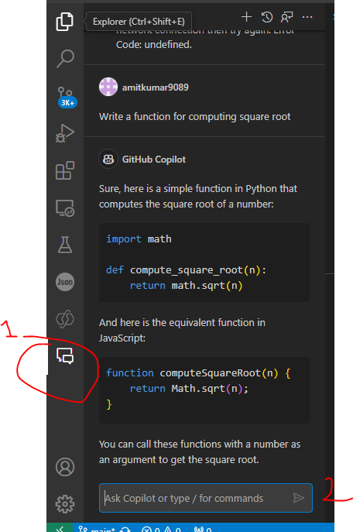

      - If you can receive the response, it means that environment is successfully configured.

